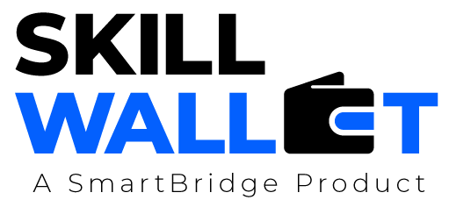

Scalability & Future Plan

Date | 13 july 2026
Team ID | SWTID-2026-2203
Project Name | Smart lender
Maximum Marks | 1 Mark

Scalability & Future Plan:
This document outlines how the current project solution can be scaled to handle larger user bases, increased data loads, or extended features in the future. It also captures the team's roadmap for enhancing and evolving the project beyond its current state.

Current System Limitations:
S.No | Limitation | Impact | Priority to Address  (High / Medium / Low)
1 | Manual Loan UnderwritingSlow | Slow decision-making and higher risk of human error. | high
2 | Reliance on Traditional Data | Missing opportunities to lend to customers with no credit history. | medium
3 | Lack of Data Security | High risk of data breaches for sensitive customer information. | high

Scalability Plan:
S.No | Scalability Aspect | Current State | Proposed Upgrade / Solution
1 | User Load | Limited concurrent users due to monolithic design. | Implement Microservices architecture to handle growth seamlessly.
2 | Data Storage | Standard relational databases for all data. | Use a Hybrid approach: NoSQL for profile data and relational for transactions
3 | Performance | Page loading and processing delays under load. | Use Predictive modeling and optimized cloud infrastructure to maintain speed.
4 | Security | Standard encryption protocols | Integrate Blockchain for immutable records and enhanced tamper-proof tracking.

Future Roadmap:
Phase | Planned Feature / Enhancement | Target Timeline | Expected Impact

Phase 2 | Advanced ML Integration (e.g., Random Forest, XGBoost, or Ensemble models) | Q3 2026 | Increases prediction accuracy and reliability by comparing multiple algorithms.
Phase 3 | Explainable AI (XAI) (e.g., SHAP or LIME integration) | Q4 2026 | Provides transparency by explaining why a loan was approved or rejected.
Phase 4 | Explainable AI (XAI) (e.g., SHAP or LIME integration) | Q1 2027 | Enables instant loan decisioning and improves customer accessibility 24/7.

